EXT750 SWING
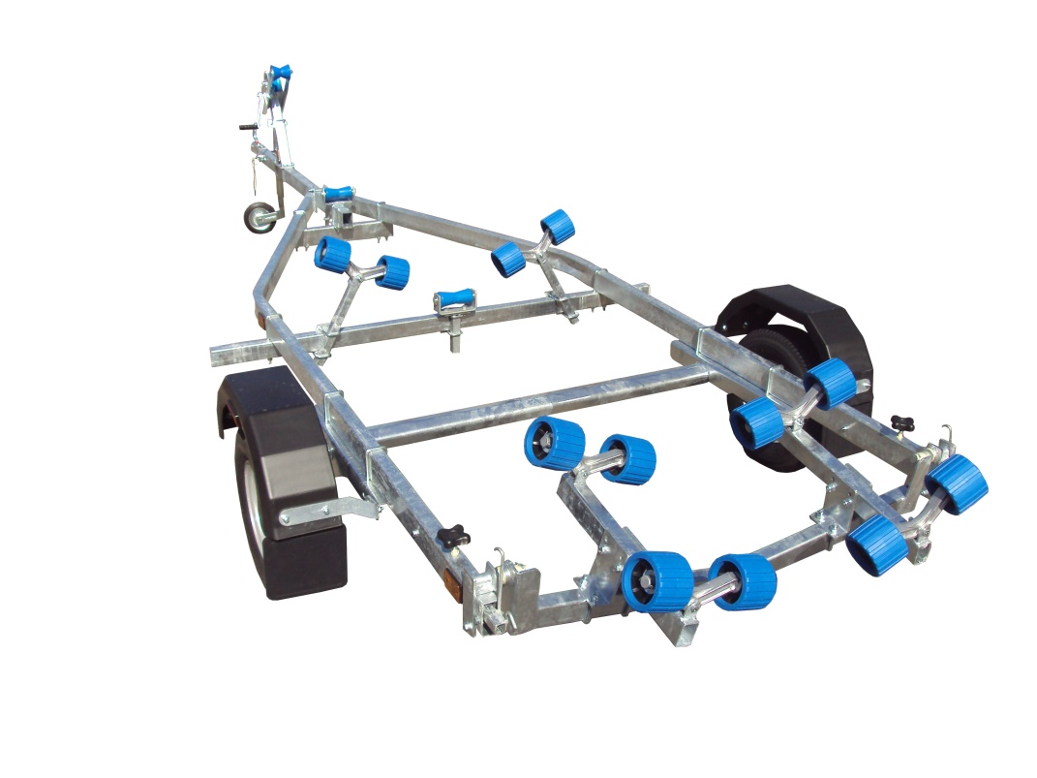
BRAND NEW EXT750 SWING GALVANISED BOAT TRAILER.

Suitable for dinghies up to 17’ (with overhang), 16’ hard boats and 5.3m ribs.

With a trailer weight of 170kg it can take 580kg of boat weight

Designed and manufactured in the UK.

Standard features include:

Heavy duty frame
AL-KO axle
Waterproof sealed bearings
Adjustable swinging arm
12 nylon non marking wobble rollers
2 heavy duty keel rollers
Heavy duty height adjustable winch post
10" wheels
42mm jockey wheel
1400lb Dutton Lainson winch
Light board on extendable bars

Everything on this trailer is adjustable, so it can fit most hull shapes.

Overall length: 5.24m

Overall width: 1.84m

RRP: £1456

