EXT2600 BUNK
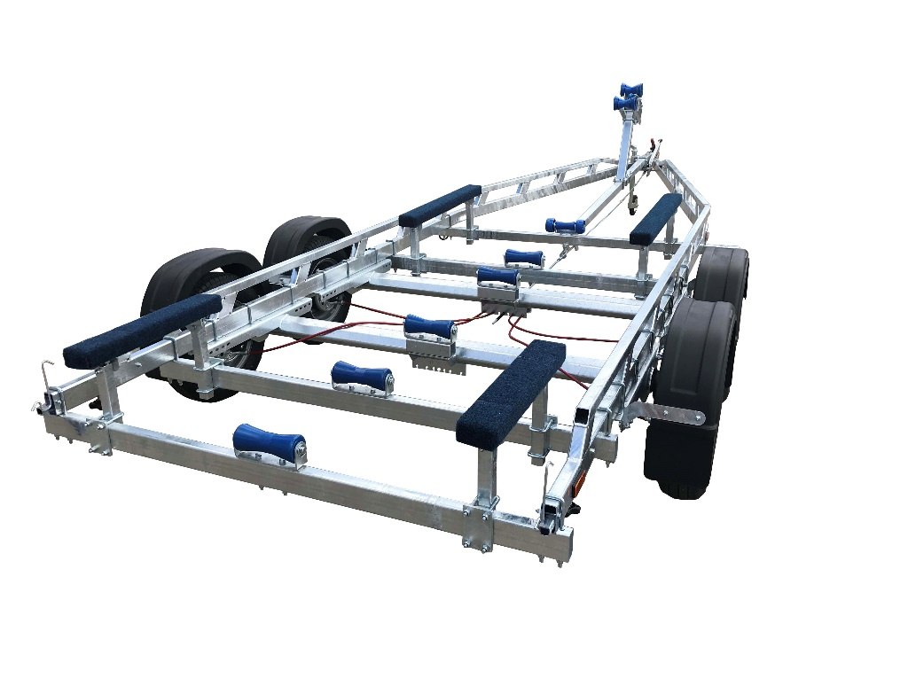

BRAND NEW EXT2600 BUNK GALVANISED BOAT TRAILER.

Suitable for dinghies up to 24'(with overhang), 22' hard boats and 7.2m ribs.

With a trailer weight of 550kg it can take a boat weight up to 2050kg.

Designed and manufactured in the UK.

Standard features include:

Heavy duty ladder frame
2 AL-KO axles
Waterproof sealed bearings
1m bunks
5 Heavy duty keel rollers
Heavy duty height adjustable winch post
165R13” wheels
42mm jockey wheel
2500lb Dutton Lainson winch
Light board on extendable bars

Overall length: 7.50m

Overall width: 2.37m

RRP: £4215

