EXT1900 SUPER ROLLER
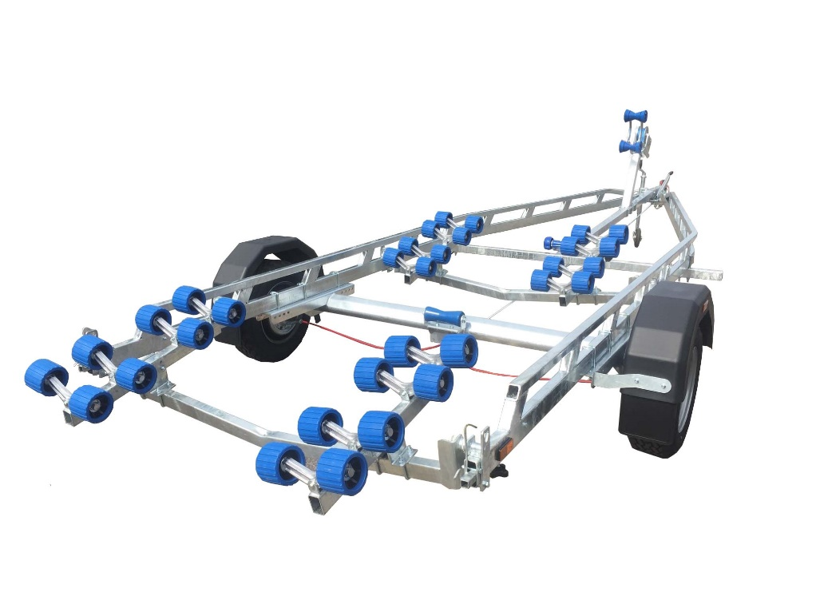

BRAND NEW EXT1900 SUPER ROLLER GALVANISED BOAT TRAILER.

Suitable hard boats up to 21" and 7.0m ribs.

With a trailer weight of 400kg it can take a boat weight up to 1500kg.

Designed and manufactured in the UK.

Standard features include:

Heavy duty frame double ladder
AL-KO axle
Waterproof sealed bearings
32 nylon non marking wobble rollers
2 swinging arms
2 heavy duty keel rollers
Heavy duty height adjustable winch post
185R13C wheels
42mm jockey wheel
2500lb Dutton Lainson winch
Light board on extendable bars

Everything on this trailer is adjustable, so it can fit most hull shapes.

Overall length: 7.00m

Overall width: 2.37m

RRP: £3442

