EXT1800 SUPER ROLLER

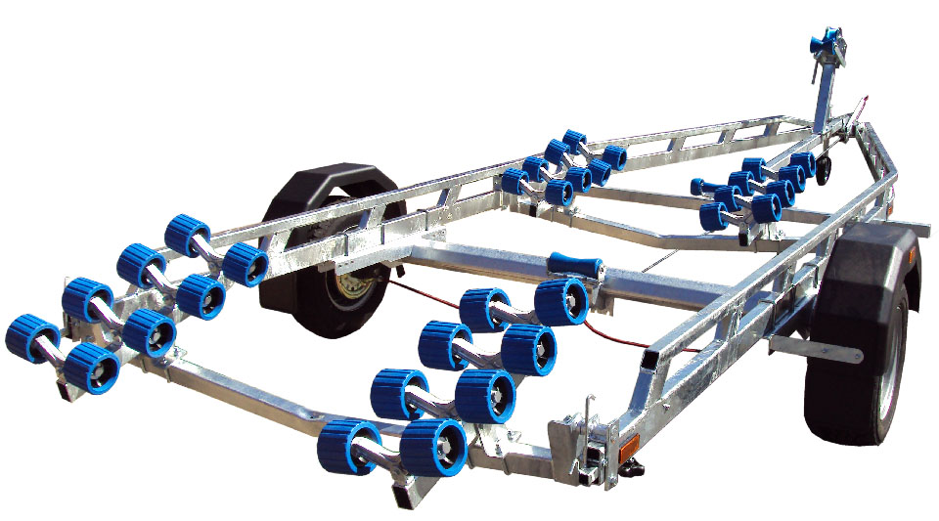

BRAND NEW EXT1800 SUPER ROLLER GALVANISED BOAT TRAILER.

Suitable for hard boats up to 18" and 6m rib

With a trailer weight of 385kg it can take a boat weight up to 1415kg.

Designed and manufactured in the UK.

Standard features include:

Heavy duty frame double ladder
AL-KO axle
Waterproof sealed bearings
32 nylon non marking wobble rollers
2 adjustable swinging arms
Heavy duty height adjustable winch post
185R13C wheels
42mm jockey wheel
2500lb Dutton Lainson winch
Light board on extendable bars

Everything on this trailer is adjustable, so it can fit most hull shapes.

Overall length: 6.55m

Overall width: 2.20m

RRP: £3242

