EXT1900 BUNK
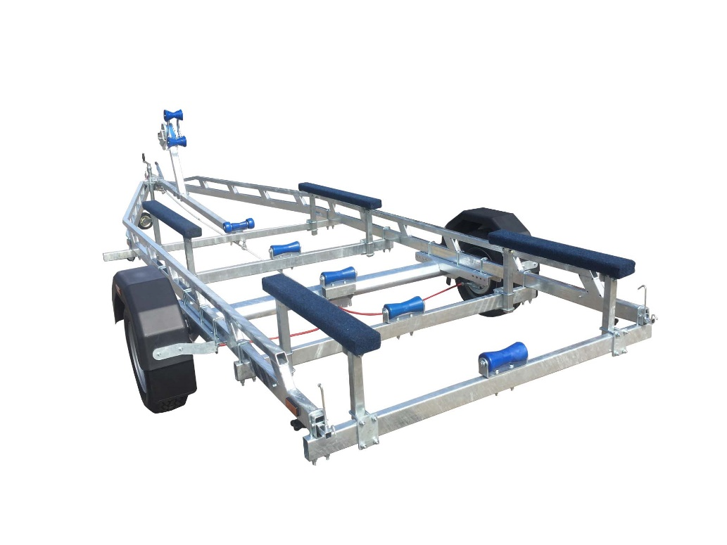

BRAND NEW EXT1900 BUNK GALVANISED BOAT TRAILER.

Suitable for dinghies up to 23'(with overhang), 21' hard boats and 7m ribs.

With a trailer weight of 400kg it can take a boat weight up to 1500kg.

Designed and manufactured in the UK.

Standard features include:

Heavy duty frame
AL-KO axle
Waterproof sealed bearings
1m bunks
5 Heavy duty keel rollers
Heavy duty height adjustable winch post
185R13” wheels
42mm jockey wheel
2500lb Dutton Lainson winch
Light board on extendable bars

Overall length: 7.00m

Overall width: 2.37m

RRP: £3442

